**Effect of Swelling on Multiple Energy Transfer in Conjugated Polymer Nanoparticles**

Louis C. Groff, Yifei Jiang, Xiaoli Wang, and Jason D. McNeill

**KEYWORDS**

Diffusion, Energy Transfer, Modeling, Decay Kinetics, Anisotropy

**ABSTRACT**

Many key processes in conjugated polymers are strongly influenced by multiple energy transfer (i.e., exciton diffusion). We investigated the effect of solvent-induced swelling on the kinetics of multiple energy transfer in nanoparticles of the conjugated polymers PFBT and MEH-PPV. Multiple energy transfer between equivalent chromophores results in loss of fluorescence polarization, which can be observed in the fluorescence anisotropy decay kinetics. Additionally, multiple energy transfer affects the rate of quenching by intrinsic or extrinsic [this needed?] defects. We found that the rate of energy transfer between chromophores is highly sensitive to solvent effects, occurring at a rate of 1.1109 s-1, and 3.3109 s-1 for PFBT and MEH-PPV dissolved in THF, respectively, and at rates 10-60 times higher in both moderately swelled, and aqueous nanoparticle suspensions. A discrete cubic lattice model incorporating distance-dependent multiple energy transfer and quenching by defects was employed to elucidate the relationships between solvent-induced swelling, fluorescence quantum yield, and decay kinetics. The simulation results show good agreement with experimental results at low to moderate THF concentrations. The results support quenching by defects or polarons, amplified by multiple energy transfer, as a likely explanation for the [typically] low fluorescence quantum yield of conjugated polymer particles as compared to the free polymer in solution [as well as similar effects observed in thin films?].



**INTRODUCTION**

Conjugated polymers (CPs) are a versatile class of semiconducting fluorescent materials, used ~~predominantly~~ as active materials in organic photovoltaics and light-emitting diodes.1,2 Conjugated polymer nanoparticles (CPNs) have extraordinary figures of merit, such as high fluorescence quantum yield, high extinction coefficients, exceptional photostability, and excellent spectral overlap with red-emitting fluorescent dyes and polymers, making them well-suited for fluorescence based imaging applications.3-7 To further develop these technologies, it is necessary to understand the complex photophysics exhibited by these polymers, which are greatly affected by polymer structure and processing conditions.8,9 In particular, the presence of aggregate species common in both CPNs and thin films, such as H- and J-aggregates, excimers, and exciplexes, the presence of chemical defects within the polymer structure, or excess charges (i.e. photogenerated hole polarons) are known to have significant effects on steady-state spectra, fluorescence lifetimes, and fluorescence quantum yield of CPs.10-13 The complexity of the observed fluorescence characteristics of CPs and CPNs arises from a multiple Förster resonance energy transfer (FRET) process, which facilitates the [does it help the process, or is it the process?] propagation of ~~neutral photoexcitations, or~~ singlet Frenkel excitons, along or between polymer chains.14 Upon photon absorption, an exciton is generated on a given chromophore in the polymer, which consists of one or more monomer units [this sentence comes across as a somewhat sloppy/improper definition of exciton. Also late, since you introduce the term above.]. The rate of exciton motion throughout the polymer is determined by the relation that FRET efficiency is proportional to both the radius of an exciton to a neighboring chromophore as *R*-6, as well as the orientation of transition dipoles between adjacent chromophores. It follows that the probability that an exciton will undergo FRET is highest for nearest neighbor chromophores with well-aligned transition dipoles. Thus, it is hypothesized that a densely packed matrix of chromophores, such as that of a CPN, will have an increased rate of exciton motion compared to the linear polymer in good solvent. It has been confirmed in previous work that the presence of defects, hole polarons, or aggregates within the polymer structure, contributes to the complexity of exciton decay rates [are rates complex??], and the observed difference in fluorescence quantum yield of CPNs compared to the corresponding polymers in THF.15

Here, we investigate the effects of solvent-induced swelling on the rate of multiple energy transfer in CPNs, as well as the reversibility of quenching by defects via swelling, using a combination of steady-state and time-resolved spectroscopic methods, coupled with [in conjunction with? including a comparison with the predictions of?] a lattice model that accounts for the effects of lattice swelling and quenching by defects. Similar methods were utilized previously to measure [determine?] the length scale of exciton motion in dye-doped CPNs (~12 nm).15 As a good solvent such as THF is added into the CPN system [aqueous CPN suspension?], the tightly-packed polymer network swells, which leads to an increase in the equilibrium chromophore spacing, which yields a reduction in the rate of multiple energy transfer. This reduction in rate is due to a restriction of access to neighboring chromophores between chains as chromophore spacing increases [not sure “restriction of access to neighboring chromophores” is clear or accurate]. As exciton motion becomes more confined, a concomitant reduction in quenching is observed, since some excitons will not be in regions encompassed by the quenching radii of defects [maybe something like “the number and probability of paths between a given chromophore and a quencher are reduced”?]. As the ratio of good solvent is increased further, CPNs dissociate into free polymer, and the fluorescence characteristics of the polymer in good solvent are recovered. In order to monitor the changes in multiple energy transfer rates at each solvent ratio, we developed an approach using picosecond fluorescence anisotropy decay, which allows for the calculation of energy transfer rates from the results of fitting the constituent intensity decays to a complex sum of exponentials [too much detail for intro].16 This is utilized in conjunction with the model, as the rate of exciton motion can also be calculated from the multiple energy transfer probability after matching experimental and simulated quenching efficiency and fluorescence intensity decays [not at all clear what you’re trying to say here. Our results indicate that multiple energy transfer is amplified in the CPN state compared to free polymer, and that an apparent tradeoff exists between the rate of exciton mobility [there is no such thing as “rate of exciton mobility”. Maybe rate of exciton transport, or exciton mobility] and fluorescence quantum yield for polymers with similar amounts of defect quenching, which provides some explanation for the wide range of fluorescence quantum yield observed for different conjugated polymers.

**EXPERIMENTAL METHODS**

**Materials.** The copolymer poly[(9,9-dioctylfluorenyl-2,7-diyl)-*co*-(1,4-benzo-{2,1',3}-thiadiazole)] (PFBT, MW 10,000, polydispersity 1.7), and the poly(phenylene vinylene) derivative poly[2-methoxy-5-(2-ethylhexyloxy)-1,4-phenylenevinylene] (MEH-PPV, MW 200,000, polydispersity, 4.0) were purchased from ADS Dyes, Inc. (Quebec, Canada). The fluorescent dye fluorescein was purchased from Life Technologies (Invitrogen, Eugene, OR). The fluorescent dye Lucifer Yellow CH dipotassium salt (LY, 1 mg/mL in water), solvent tetrahydrofuran (THF, anhydrous, inhibitor-free, 99.9%) and sodium hydroxide (SigmaUltra, minimum 98%) were purchased from Sigma-Aldrich (Milwaukee, WI). All materials were used as provided without further purification.

**Nanoparticle Preparation.** The preparation of fluorescent nanoparticles was performed via a previously described nano-precipitation method.17 The conjugated polymers PFBT and MEH-PPV were dissolved in THF by gentle agitation and prepared at a concentration of 1000 ppm. An aliquot of each stock solution was used to prepare precursor solutions at 20 ppm. A 2 mL quantity of a given precursor solution was rapidly added into 8 mL of deionized water under bath sonication at a frequency of 40 kHz and room temperature. Removal of THF was accomplished by the following procedure. Nanoparticle suspensions were placed in a vacuum oven under nitrogen flow for 8 hours at room temperature in order to remove enough THF to prevent bumping during the subsequent vacuum evaporation step. Nitrogen flow was ceased and samples were [evaporated under vacuum in a vacuum oven at room temperature] ~~pumped down~~ ~~to an atmosphere of <10 torr~~ [not really--that is the pump’s base pressure, not the pressure achieved.] using a two-stage rotary vane pump [with a base pressure of ~XX torr]. The samples were heated at ~40 °C for 6-7 hours to remove most of the remaining THF. The total volume of liquid was reduced by typically 60% during the vacuum evaporation process [sorry if this is a repeat, but does a basic iterated Henry’s Law calculation indicate that this is enough?]. No residual THF odor was detected in the aqueous samples. [Also, at this point, further evaporation yielded no change in the fluorescence spectrum or quantum yield?] We validated this process further by assessing the [batch-to-batch?] reproducibility of the fluorescence spectra, and fluorescence quantum yield of the nanoparticle samples. Four samples [batches?] for each polymer were prepared. The nanoparticle fluorescence spectra were invariant in shape and peak emission wavelength for both polymers. The fluorescence quantum yield varied between 4%-6% for PFBT CPNs, and remained constant at ~1% for MEH-PPV CPNs. The aqueous samples were vacuum filtered through a glass fiber prefilter to remove larger aggregates and a 0.1 µm PVDF membrane filter (Millipore). The resulting suspensions are clear (not turbid) and stable for months with no visible signs of aggregation.

**Characterization Methods.** UV-Vis absorption spectra were acquired using a Shimadzu UV2101PC scanning spectrophotometer with 1 cm quartz cuvettes. Fluorescence spectra and fluorescence quantum yield were measured using a commercial fluorimeter (Quantamaster, Photon Technology International) using 1 cm quartz cuvettes.

Picosecond fluorescence lifetimes and fluorescence anisotropy decay (FAD) were measured under nitrogen using a home-built setup for time-correlated single photon counting (TCSPC) spectroscopy operating in reverse mode. Frequency doubled pulses (420 nm) from a passively mode-locked Ti:Sapphire laser (Coherent Mira 900, 840 nm pulses, ~150 fs pulsewidth) were used as the excitation source for the nanoparticle samples. Sample emission was collected with perpendicular geometry to the excitation source after passing through a 460 nm long pass filter, and a calcite Glan-Taylor polarizer (Thorlabs, GT10-A) oriented either parallel (0°), perpendicular (90°), or at magic angle (55°) to the vertically polarized excitation pulses. All three polarization angles were utilized for FAD, magic angle polarizer orientation was adopted for TCSPC. The output of a single photon avalanche photodiode (APD, id Quantique, id100-50) was used as the start timing pulse for a time-to-amplitude converter (TAC, Canberra Model 2145), and the output of a fast PIN diode (Thorlabs, DET210) was used as the stop pulse, in a standard reverse-mode configuration.16,18 The excitation power was attenuated (usually between ~300 µW and 1 mW) to maintain a count rate of ~400 kHz as measured at the APD. The analog TAC output was digitized using a multi-channel analyzer (FastComTec, MCA-3A). Before and after each measurement, an instrument response function (IRF) was measured using scattered excitation light from a dilute suspension of polystyrene microspheres. The width of the IRF was determined to be ~70 ps (fwhm). Typical peak signal-to-noise ratios (SNR) [for each run? How many runs were collected?] were between 200:1 (80%-100% THF samples) and 500:1 (IRF and low-mid % THF samples). The reported information was collated from a total of two samples per concentration of THF, and 3-5 scans per sample. Intensity decays were collected for 5-20 minutes to obtain the above mentioned SNR values, depending on the lifetime of the sample.[note: if the method for obtaining the anisotropy gives a big flat offset, like in the powerpoint slide we discussed, then fit to a single exponential plus offset, not bi-exponential]

**Swelling Procedure.** In addition to nanoparticles in water and polymer in THF, swelled nanoparticle samples were prepared by diluting an aliquot of concentrated nanoparticle suspension with the appropriate volume of water, followed by slowly adding THF to produce 3 mL of suspension with volume ratios of THF/water between 0.2 and 0.95. Each sample was gently agitated to ensure solution homogeneity. The sample absorbance was kept at or under ~0.05 (~0.02 for 95% THF). Samples were purged with nitrogen for ~2 minutes, in order to limit loss of THF.

**RESULTS/DISCUSSION**

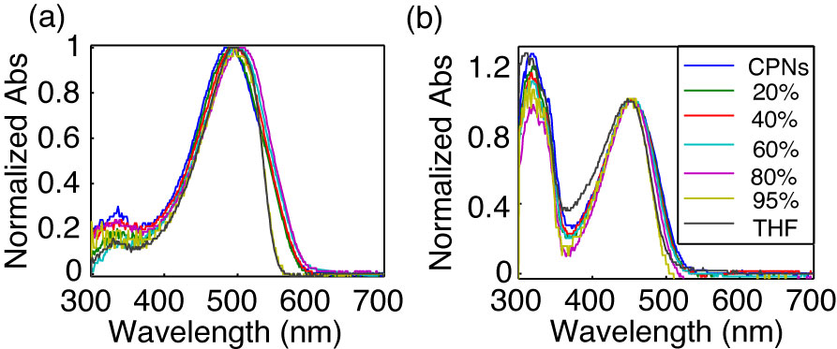

**Fig. 1.** Normalized absorption spectra of (a) MEH-PPV and (b) PFBT at varying volume % THF.

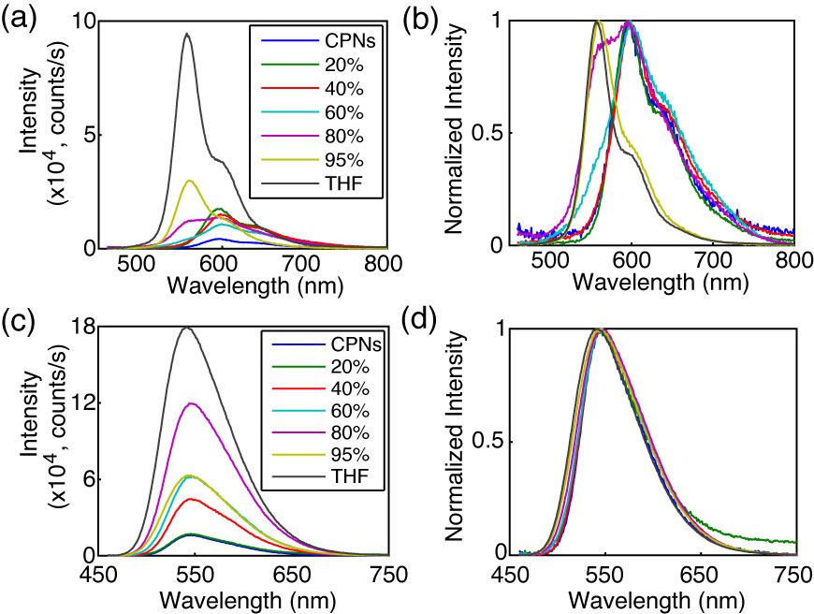

**Fig. 2.** (a,c) Absolute and (b,d) normalized emission spectra of MEH-PPV (top) and PFBT (bottom) at varying volume % THF.

**Effect of solvent composition on UV-vis and fluorescence.** The UV-vis and fluorescence spectra of PFBT and MEH-PPV as a function of solvent composition are given in Figs. 1 and 2. The absorption spectra of PFBT maintain a similar shape with increasing THF, with a ~5 nm total blue shift, and slight broadening of the THF sample spectrum [what do you mean by “of the THF sample spectrum” in this context?]. The emission spectra show a monotonic increase in fluorescence intensity as the concentration of THF increases, and the spectra also exhibit a blue shift ~5 nm ~~over the course of~~ [with?] increasing THF. The absorption spectra of MEH-PPV maintain a similar shape as THF concentration is increased, though the 95%-100% THF spectra are narrower than the spectra of the other samples. The absorption peak of MEH-PPV red shifts a total of ~15 nm from 0%-80% THF, and then blue shifts ~7 nm for the 95%-100% THF samples. The emission peak blue shifts a total of ~40 nm as THF composition is increased, and it ~~is evident~~[appears that] from ~40% THF to 80% THF ~~that~~ there are [possibly] two phases present in solution by[based on?] the increase in intensity of the ~560 nm shoulder on the spectrum, and the reduction in intensity of the ~600 nm shoulder of the spectrum as % THF increases. An approximate isosbestic point can be seen at ~580 nm over the concentration range of ~60%-80% THF.

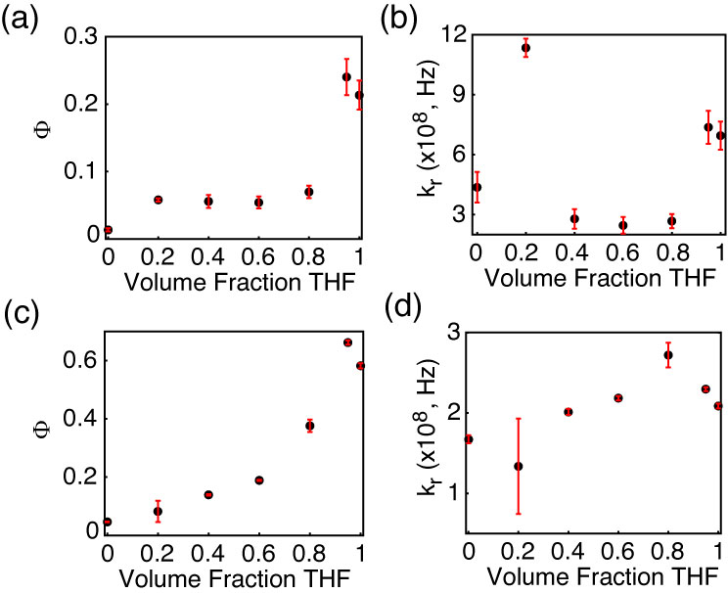

**Fig. 3.** (a,c) Fluorescence quantum yield and (b,d) radiative rate vs. THF volume fraction for MEH-PPV (top) and PFBT (bottom).

The fluorescence quantum yields ( and calculated radiative rates, where the radiative rate is defined [I would use “given by” “obtained from the lifetime results using” rather than “defined” because I usually think of a definition as more fundamental, such as enthalpy defined as heat at constant pressure] as are given in Fig. 3. The quantum yield of PFBT increases monotonically with increasing THF. However, MEH-PPV shows an initial intensity increase from 0%-20% THF, followed by the quantum yield staying relatively consistent from 20% to 80% THF, then increasing at higher %THF. The [I find this troubling. Do we need to correct this data or re-run it? What is the magnitude of the discrepancy?] higher quantum yield of the 95% sample relative to the polymers in THF is ascribed to the uncertainty in the absorbance at such low concentrations of PFBT and MEH-PPV. The quantum yield remains relatively constant for MEH-PPV at moderate THF concentrations, and can be ascribed to the trade-offs in intensity between the ~560 nm shoulder and the ~600 nm shoulder of the spectrum [that’s not really an explanation. delete it?]. The radiative rate varies over a factor of ~2 for PFBT and a factor of ~4 for MEH-PPV over the ~~course of increasing~~[range of?] THF concentration.



It is possible that the results outlined in Figs. 2 and 3 indicate that transition dipole coupling is somewhat stronger for MEH-PPV compared to PFBT. This is made more evident by closer analysis of the spectra. Transition dipole coupling leads to a pronounced red shift in both the absorption and emission spectra, which is observed in the MEH-PPV emission spectra, while the PFBT spectral shift is small in both the absorption and emission spectra. It is possible that the lesser red shift in the absorption spectra of MEH-PPV can be explained by a smaller number of chromophores in MEH-PPV having their transition dipoles strongly coupled compared to the total number of chromophores per CPN.[perhaps we should have some discussion of the “two-state” picture of Barbara as well? I think basically the idea is that there is a minority “aggregate” state that is red-shifted, weakly fluorescent, and acts as an energy acceptor. The two pictures are of course not mutually exclusive and they sort of blend into each other depending on what the definition of “minority” is.]

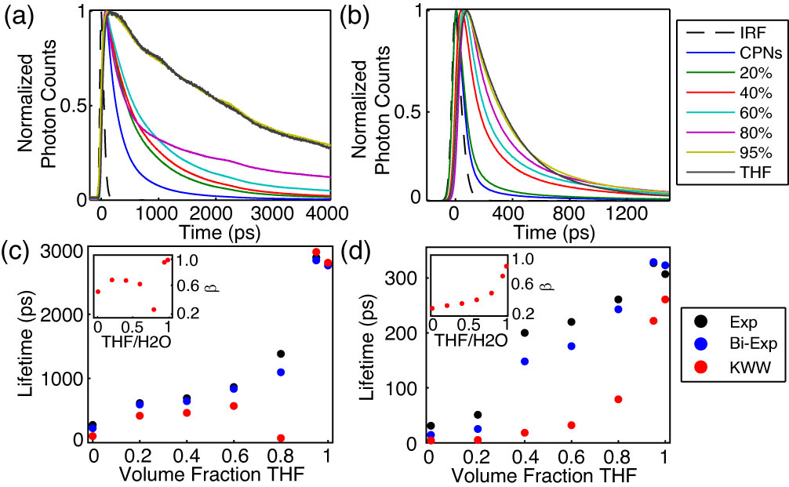

**Fig. 4.** (a,b) Normalized fluorescence intensity decays, and (c,d) lifetimes resulting from single exponential, bi-exponential weighted average, and KWW trial functions with stretch parameter ** insets) versus THF volume fraction for PFBT and MEH-PPV, respectively.

**Table 1.** Summary of results of bi-exponential least-squares fitting to time-resolved fluorescence of MEH-PPV and PFBT CPNs, including weighted amplitudes (***A1***, ***A2***) and individual exponential time constants (***1*********).

|  |  |  |  |  |  |  |  |  |
| --- | --- | --- | --- | --- | --- | --- | --- | --- |
| **Volume Fraction THF** | **MEH-PPV** | | | | **PFBT** | | | |
| ***A1*** | ***1* (ps)** | ***A2*** | ***2* (ps)** | ***A1*** | ***1* (ps)** | ***A2*** | ***2* (ps)** |
| **0** | 0.96 | 9 | 0.04 | 150 | 0.59 | 88 | 0.41 | 420 |
| **0.20** | 0.93 | 14 | 0.07 | 180 | 0.51 | 260 | 0.49 | 940 |
| **0.40** | 0.73 | 56 | 0.27 | 400 | 0.51 | 280 | 0.49 | 1000 |
| **0.60** | 0.75 | 74 | 0.25 | 480 | 0.55 | 360 | 0.45 | 1400 |
| **0.80** | 0.75 | 120 | 0.25 | 620 | 0.65 | 230 | 0.35 | 2700 |
| **0.95** | 0.80 | 220 | 0.20 | 760 | 0.02 | 230 | 0.98 | 2900 |
| **1** | 0.95 | 270 | 0.05 | 1300 | 0.01 | 270 | 0.99 | 2800 |

**Picosecond Time-Resolved Fluorescence Spectroscopy.** TCSPC obtained at magic angle to the excitation source was employed to measure the excited state decay kinetics of both CPN systems over the range of solvent composition. The trial functions employed during iterative reconvolution fitting analysis were single exponential, bi-exponential, and the Kolrausch-Williams-Watts (KWW) function or stretched exponential, given by , where ** is the stretch parameter. Values for ** are typically between ~0.3 and 1, where lower values correspond to a broader distribution of lifetimes for a given sample, and **   corresponds to a single exponential lifetime.19 The fits to all three trial functions converged for all samples. With exception of PFBT in THF which was fit best by a single exponential, the remaining intensity decays fit best to bi-exponential and KWW trial functions[, indicating heterogeneous kinetics?]. The representative intensity decays for each sample, along with the respective time constants and **versus THF volume fractionare given in Fig. 4. The lifetimes for both systems follow a generally increasing trend as THF concentration increases. The lifetimes of the CPN samples in water are shorter than previously reported (~275 ps versus ~700 ps previously for PFBT), but can be ascribed to a more complete THF removal process, as evidenced by the accompanying reduced quantum yield ( = 0.04 versus  = 0.14 previously for PFBT CPNs). ** generally increases for both systems as the fraction of THF increases, beginning at ~0.3 for MEH-PPV in water and increasing monotonically to ~0.8 for MEH-PPV in THF, indicating that MEH-PPV in solution [...that even in good solvent MEH-PPV exhibits...] exhibits complex ~~exponential~~ decay kinetics. Conversely,[not sure if conversely is right here] ** for PFBT increases [monotonically? more or less monotonically?] from ~0.6 for CPNs in water to unity in THF. A substantial decrease in* * is observed for PFBT from ~0.7 at 60% THF to ~0.3 at 80% THF, and is indicative of a dramatic increase in the distribution of exciton lifetimes. The trends in ** are hypothesized to be due to changes in the rates of exciton energy transfer to the distribution of quenchers, which result from increases in equilibrium chromophore spacing as THF concentration increases. [This hypothesis(picture?) is supported by prior results of dye-doped CPNs, which indicated a reduction in beta as additional quenchers (dyes) were introduced.[ref]] The net effect is that the distribution of quenchers becomes less accessible (to excitons?) as the physical spacing between chains increases, contributing to the increases in **[or maybe a different approach, such as saying that on average, an exciton is less likely to fall within the quenching volume of a quencher. Also, either here or in a separate paragraph or in a different paragraph, the “two-state” picture ought to be discussed within the context of beta] Additionally, it was found in previous work on dye-doped CPNs that ** is also roughly proportional to the ratio of *LD*/*R*0,15 where *LD* is the exciton diffusion length, and *R*0 corresponds to the Förster radius of a given quencher. Given that *R*0 is assumed to be fixed in this system, an increase in *LD* results in an increase in **, since an increase in *LD* increases the probability of a given exciton successfully escaping the Förster radius of a quencher.15 [however, the model also predicts increased quenching as LD increases, which is the opposite of what we see here, so this candidate explanation fails to account for the results] The implications[word choice?] of the results of the fitting analysis are discussed below.



A summary of the bi-exponential least-squares fitting results is given in Table 1. It can be seen that starting at 40% THF for MEH-PPV and 80% THF for PFBT, the individual exponential time constants approximately reproduce[???] the nanoparticle lifetime in 1, and the free polymer lifetime in 2.[Observations in previous sentence vague. Debatable (as stated). Not sure if it belongs here--perhaps in a separate paragraph (after the “main” ideas), and perhaps taken together with the Barbara 2-state picture (with refs) ] For MEH-PPV, the longer time constant increase monotonically with increasing THF fraction,[I reworded this sentence because it still had some residual time-dependence (“...as THF increases...”) which is distracting since we are talking about ps timescale as well] and the weighted amplitudes do not change appreciably except for MEH-PPV in [100%] THF [where it does what?]. Conversely,[not a big fan of “conversely”, except in logic/philosophy] the time constants remain approximately the same for PFBT between 80-100%, and the weighted amplitude corresponding to the long time constant increases from 80-100% THF. Thus, the lifetime results [perhaps] suggest a two state-like system, in which CPNs and free polymer coexist in equilibrium, within a narrow range of THF concentrations. A more detailed discussion of the implications of this picture will be discussed in a later section.[redundant (“discuss” used twice) and awkward. Also, “implications” may be a bit too string for just 2-3 data points and given that there’s nothing terribly surprising about the idea of a sort of dynamic equilibrium between free and aggregated]

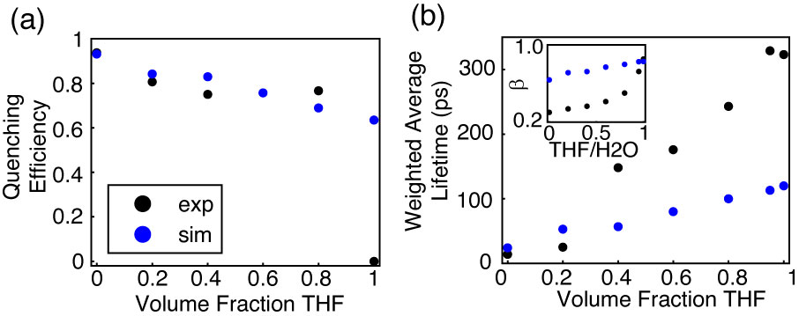

**Fig. 5.** Comparison of simulated (blue) and experimental (black) (a) quenching efficiency, (b) average lifetime, and (inset) KWW stretch parameter *ß* versus THF volume fraction for MEH-PPV.

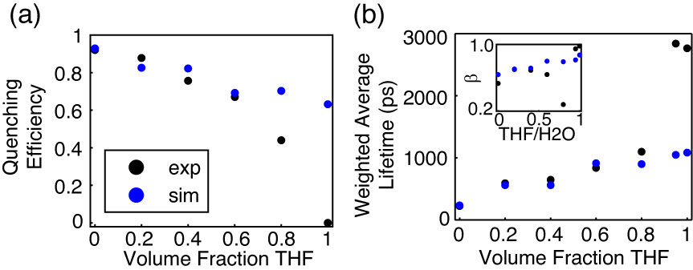

**Fig. 6.** Comparison of simulated (blue) and experimental (black) (a) quenching efficiency, (b) average lifetime, and (inset) KWW stretch parameter *ß* versus THF volume fraction for PFBT.

**Lattice Swelling Model.** Exciton transport in conjugated polymers can be described as a multiple energy transfer process in which exciton energy transfer[? non-standard] occurs [one or more times?] between [equivalent?] chromophores along or on adjacent chains [awkward construction. Maybe better to use more words] prior to radiative/nonradiative [should try to avoid the slash in papers] decay or FRET to ~~intrinsic~~ [whether or not they are intrinsic is somewhat irrelevant in this paragraph] quenching species (e.g. nonfluorescent chemical defects or redshifted [, weakly fluorescent] aggregate[s] ~~chromophores~~). A tightly-packed polymer chain network [awkward. Not really a network. Not really so tight--similar to film.] such as that of a CPN facilitates energy transfer to both chromophores and quenchers, resulting in efficient fluorescence quenching due to the high mobility of excitons in conjugated polymers, as well as a significantly reduced exciton lifetime (np ~ 275 ps versus poly ~ 2.8 ns for PFBT). Introduction of a good solvent results in swelling of the polymer network, which increases the physical[?] spacing between individual chains, as well as any quenching species that may be present on each chain. Due to the R-6 distance dependence of FRET, increases in average chromophore spacing lead to a reduction in energy transfer rates, reducing both exciton mobility and quenching by ~~intrinsic species~~ [defects]. At the highest concentrations of good solvent, CPNs dissociate into free polymer chains, and the rate of energy transfer is further reduced, reproducing the energy transfer rate in good solvent. This reduction is due to the limited number of nearest neighbor chromophores accessible for a given exciton to undergo energy transfer to.[Long and meandering, possibly repetitive. you need to carefully consider what is the main point of the preceding 5 sentences and see if you can boil it down to a sentence.]

A discrete lattice model was employed in order to simulate the effect of solvent-induced swelling on exciton quenching and decay kinetics using a numerical random walk algorithm.[word order. ambiguous what is “using” the RW model] This approach was previously utilized to model exciton diffusion and energy transfer in dye-doped nanoparticles, both on a discrete cubic lattice,5 ~~and in a continuum model that included quenching by defects, in which a spherical particle was assumed.~~~~15~~ [A related approach] ~~method~~ was ~~also~~ employed to model fluorescence centroid fluctuations due to polaron motion on single CPNs.20 ~~In this model, a cubic particle is assumed.~~ [Here, we represent the particle as a cubic lattice.] Each lattice point represents one chromophore, with lattice spacing (*x*) determined by the cube root of the volume of one chromophore, assumed to be comprised of two monomer units. Excitons undergo energy transfer between nearest neighbor chromophores, and the energy transfer rate is set to reproduce the observed exciton diffusion length from previous work of *LD* = 12 nm, which is assumed for both polymers.15 The exciton energy transfer probability for a random walk in the absence of swelling is given by , where *t* is the time step, andD is the exciton diffusion constant given by , where  is the lifetime of the polymer in good solvent.[I don’t like _poly, since it is not immediately clear that this is the lifetime without quenching. Also, it would be clearer to specify that this is the lifetime in the absence of quenching rather than forcing the reader to reason through to that in 3 steps (1. “poly” means the dissolved polymer (even though that is not clear), 2. The dissolved polymer has negligible quenching. 3. therefore this is the lifetime in the absence of quenchers.)]



In order to account for solvent-induced swelling, we assume that swelling occurs in a similar fashion to other structurally similar polymers such as polystyrene (PS). As such, increases in the lattice spacing were calculated using particle sizing results obtained by Carson, et al. via optical microscopy on PS beads swelled with THF.21 A swelling factor, which accounts for increases in nanoparticle size as THF concentration increases, is given by, where *d* and *x* are the swelled and unswelled lattice spacings, respectively. The unswelled lattice spacing is calculated by taking the cube root of the approximate volume of one chromophore, which results in a spacing of 1.2 nm for PFBT, and 0.9 nm for MEH-PPV.[note: perhaps in the discussion we should discuss whether the model results are sensitive to the initial chromophore size (0.8 vs say 1.5 nm)--my gut feeling is that it is not very much, since we would scale the energy transfer rate to reproduce LD. Maybe you have some results on this already] The swelled lattice spacing [sugg: increase in the interchromophore distance due to swelling?] is calculated by multiplying *x* by the percentage increase in bead diameter given by the PS results [sounds a bit unscientific, and also “multiplying by a percentage increase” sounds nonstandard or ambiguous. How about “scaling the interchromophore spacing to match the PS/THF swelling results” or similar. I also favor using chromophore-chromophore spacing or interchromophore spacing more often than “lattice spacing”]. The exciton energy transfer probability was reduced by a factor given by , [is there a typo there, or do you have k in the exponent on both sides, which would cancel maybe (my Algebra skills are gone today)] which arises from [based on?] the well-known result that transition dipole coupling strength in excitonic systems is proportional to the lattice spacing [inter-chromophore dist?] raised to a power *k*, which is a constant typically between 2-4, assumed to be 2 for these polymers.22 [these (exact) polymers, or similar polymers, or similar chromophores?] The time step size was adjusted so that initially,[what do you mean by initially in this context? Also, perhaps it is better to use words rather than the inequality:] . An integer number of quenchers replace chromophores on the lattice [that is a calculation distinction without a difference--better to just say they are placed at random on the lattice, rather than saying the chromophores are replaced], each with an assumed quenching radius of 4 nm, similar to that of a perylene red dye molecule. The mean number of quenchers per nanoparticle is determined by adding quenchers until the simulated exciton lifetime approximately reproduces the lifetime of CPNs in water. The number of quenchers for each polymer was determined to be 9 for PFBT, and 10 for MEH-PPV. The greater number of quenchers per CPN than those previously reported for dye-doped PFBT CPNs (2.2 per CPN) can be ascribed to several differences, including the use of a discrete lattice model with fixed step sizes as opposed to a continuum model with random step sizes, and a larger particle (10 nm cube) was assumed in this model. In addition, the Poisson distribution of quenchers has not been accounted for this model, which results in somewhat higher values for ** than previously reported. The exclusion of Poisson statistical effects on the system is due to the quality of fit of the model results to the experimental results in its absence (discussed below), and has been accounted for in our previous work on dye-doped PFBT CPNs.15



At low to moderate THF concentrations, the model results fit well to experimental fluorescence lifetime results and quenching efficiency, the latter defined as , where *s* and *poly* are the fluorescence quantum yields of the sample and the polymer in THF, respectively. The simulated quenching efficiency matches the experiment well up to 60% THF for PFBT, and up to 80% THF for MEH-PPV. The fitting results to the simulated intensity decays match experimental TCSPC fitting results well up to 20% THF for MEH-PPV and up to 80% THF for PFBT. ** is reproduced relatively well for PFBT over the course of THF composition, with exception of 80% THF, and is not reproduced very well for MEH-PPV, except for MEH-PPV in THF. The observed divergence between simulation and experiment outside of the above mentioned solvent compositions corresponds to the regions of moderate THF composition where it is speculated that the polymer is in two conformational states, particularly 40%-80% THF for MEH-PPV and 80% THF for PFBT. The poor agreement with experimental ** values for MEH-PPV is likely because effects from correlated chromophore orientations, and the Poisson distribution of quenchers were not accounted for in this model.



In this and previous work, it has been the aim to identify the causes of the reduced lifetime and ** between polymer in good solvent and nanoparticles in water.15 It has been hypothesized that the principal cause of the reduction in decay parameters for CPNs in water, relative to polymer in good solvent, is due to quenching by chemical defects or photogenerated hole polarons. With the assumption that multiple exciton transfer is a FRET-mediated process, it follows that the energy transfer efficiency to defect sites would depend upon the number of nearest neighbor chromophores, which is proportional to the dimensionality of the system. As an alternate perspective to the above lattice model calculations, the effect of dimensionality on quenching efficiency was investigated for PFBT, by determining how quenching efficiency differs in an ensemble of isolated, one-dimensional chains of PFBT versus a 3D spherical particle.

The information for a spherical particle is taken from the above experimental and simulated data for PFBT, in which the particle is assumed to be 10 nm in diameter, with quenching efficiency ~92%. The quenching radius *Rq* is taken from the simulations at 4 nm. For the one dimensional case, an ensemble of linear chains is assumed, the approximate integer number of chains per CPN (*Nchain*) is calculated from the relevant information for a spherical particle, and the contour length of each chain is given by , where *Lchrom* and *Nchrom* are the 1D length of one chromophore (assuming C-C bond lengths similar to benzene, yields ~2.5 nm/chromophore), and the number of chromophores per chain, respectively. A number of Poisson distributed quenchers *Nq* are assumed whose quenching radii do not overlap. The total quenched contour length is calculated by



, (1)



where the index *n* corresponds to the number of quenchers, and *Nn* is the number of chains in the ensemble containing *n* quenchers, and the quenching efficiency * * is calculated by

. (2)



Equation 2 results in ~11% quenching efficiency for the one dimensional case for PFBT, which supports the notion that even with the same quantity of quenchers in the system, quenching is greatly suppressed as the nanoparticle dissociates into free chains in solution. This also supports one assumption of our quenching picture for CPNs: that quenching by defects is greatly reduced in isolated, extended chains due to a reduction in the rate of exciton energy transfer, which stems from the reduced number of nearest neighbor chromophores available for exciton energy transfer in the 1D case, compared to the 3D case (two neighbors in 1D, versus six neighbors in 3D).

Throughout these experiments, there have been multiple results which suggest that solvent-induced swelling can result in a two-state system, such as the appearance of a significantly blue-shifted shoulder in the emission spectrum of MEH-PPV at moderate THF concentrations, which approximately matches the spectrum of the solvated polymer. Additionally, the lifetime analysis results for both polymers approximately yield the time constants of the CPNs at short times, and free polymer at long times, which hold fixed for PFBT as THF concentration increases, only shifting in the relative percent of each, as is observed in the weighted amplitudes. The model results also significantly deviate from what is observed experimentially in the region of THF concentration where these phenomena are observed. While it is beyond the scope of this article to determine whether the system is indeed in a two-state system, the possibility should not be ignored, and further work can be done in order to answer this question. For now, it can only be speculated that perhaps the system exists as both free polymer and swelled nanoparticles coexisting in solution, only within a fairly narrow range of THF concentrations, or that there may be a dynamic equilibrium between the two at moderate THF concentrations.

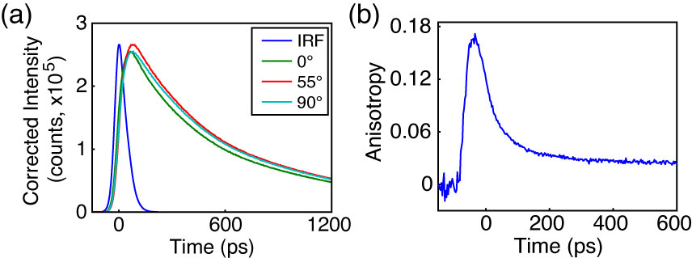

**Fig. 7.** Anisotropy data for PFBT in 40% THF. (a) Intensity decays collected at 0° (green), 55° (red), and 90° (cyan) polarizer orientations with sample IRF (blue). (b) Anisotropy decay *r*(*t*) constructed from intensity data in (a).

**Picosecond Fluorescence Anisotropy Decay (FAD).** Polarized intensity decays collected at 0°, 90° and 55° to the vertically polarized excitation pulse were obtained via reverse-mode TCSPC (c.f. Fig 7a). The resulting polarized intensity data was utilized to construct time-resolved anisotropy decays by the relation , where , , and G is a correction factor accounting for differences in detector sensitivity to vertically and horizontally polarized light (c.f. Fig 7b). The process by which the anisotropy data is calculated from the fluorescence intensity decays at each polarizer orientation was adapted from a method by Fleming et al., and is described in detail in the Supporting Information.16



Despite the high signal levels (peak SNR ≥ 500:1) in the intensity decays of the MEH-PPV samples, only MEH-PPV in solution yielded a complete set of intensity decays that were usable for fitting analysis (*r*0 = 0.07 c = 290 ps). This is likely due to limitations in the time-resolution of our instrument, as well as the low anisotropy signal relative to the overall intensity decay trace. The correlation time calculated from the fitting analysis does approximately match typical correlation times reported previously for MEH-PPV.23,24 The representative intensity decays, and constructed anisotropy decay for moderately swelled PFBT CPNs are given in Fig. 7. For 40%, 60%, 95% and 100% THF, the *r*0 values calculated from the fitting analysis procedure are 0.18, 0.08, 0.07 and 0.09, and the phenomenological correlation times (c), are 21 ps, 450 ps, 910 ps, and 920 ps, respectively. The increasing correlation times indicate that anisotropy decays more slowly as THF concentration increases. This is expected due to a reduction in the rate of exciton energy transfer as the equilibrium interchromophore distance increases due to swelling. The low (~2x to ~50x lower than the theoretical maximum of 0.4) limiting anisotropy values obtained from fitting analysis for both polymers suggest that either the transition dipoles are not initially well-aligned, or that the time window we are able to observe is after some depolarization has already occurred. From the FAD fitting analysis, it is possible to calculate the exciton energy transfer rate constant *keet* by *keet* = c-1. For the case of PFBT CPNs in 40% THF (given that more anisotropy is observed for this sample), c from the fitting analysis is 21 ps. This corresponds to an exciton energy transfer rate constant of 4.81010 s-1. Compared to the free PFBT polymer in THF, with c ~900 ps, this corresponds to *keet* = 1.1109 s-1, which suggests that multiple energy transfer between equivalent chromophores is amplified in the aggregated state, even with moderate swelling.



In order to provide a rough estimate of the correlation times for the CPNs in water, the approximate c was calculated from the model exciton energy transfer probabilities from the relation . After Taylor expansion of the exponential term, the exciton energy transfer rate constant can be approximated as . The results of these calculations yield rate constants of 2.01011 s-1 for MEH-PPV CPNs and 1.11010 s-1 for PFBT CPNs. Comparing to *keet* for the polymers in good solvent yields 3.4109 s‑1 for MEH-PPV and 1.1109 s-1 for PFBT. This indicates that the exciton energy transfer rate to six nearest neighbors (for the nanoparticles) is between ~10x and ~60x faster than the exciton energy transfer rate to two nearest neighbors (for a linear polymer in solution).



Looking at the calculated rate constants from the model in conjunction with the FAD fitting analysis results for both polymers, further speculation could be made that many of the observed photophysics for both polymers are dictacted by the exciton energy transfer rates. The results for MEH-PPV indicate that the exciton energy transfer rate of MEH-PPV is significantly higher as compared to PFBT, which would make it well-suited for applications requiring greater exciton mobility. In addition, this could lead to difficulty in accurate determination of the intrinsic exciton diffusion length for polymers such as this, since exciton motion is limited by the defect concentration, which leads to the exciton diffusion length effectively being defined by the distance between quenchers.

Conversely, the exciton energy transfer rates could provide some explanation for the significantly poorer quantum yield of MEH-PPV as compared to PFBT, which would make PFBT more useful for applications requiring a higher luminescence yield. Given that the model results yield approximately the same number of quenchers per unit volume of polymer, it follows that if exciton transport is faster, then excitons would be more efficiently funneled to defect sites, reducing the number of emission events. Thus, even though similar behavior is exhibited with regard to quenching efficiency as we move from a 3D particle to isolated 1D chains through swelling, we still see large differences in fluorescence lifetime and quantum yield, due to significant differences in exciton mobility between these polymers.

**CONCLUSION**

Steady-state and time-resolved fluorescence spectroscopic methods, coupled with a discrete lattice model were utilized to assess the effect of solvent-induced swelling on the optical spectra, exciton decay rates, and multiple exciton energy transfer rates in conjugated polymer nanoparticles. For both polymers, the fluorescence quantum yield increases with increasing THF concentration, reproducing the fluorescence quantum yield corresponding to the free polymer at 95% THF. Analysis of the fluorescence spectra of MEH-PPV exhibits a significant blue shifted component to the spectra as THF concentration increases, which provides evidence of dissociation of the nanoparticle into free polymer, over the range of 40-80% THF. A multiple energy transfer model incorporating quenching by defects yielded good agreement to experimental quenching efficiency and TCSPC results at low to mid THF concentrations. The model results yielded energy transfer rate constants of 2.01011 s-1 for MEH-PPV CPNs and 1.11010 s-1 for PFBT CPNs, and FAD fitting analysis yielded *keet* = 4.81010 s-1 for moderately swelled PFBT CPNs, which are 10-60 times higher than the values of *keet* obtained for the corresponding polymers in THF. Calculations assessing the effect of dimensionality on quenching efficiency yield an order of magnitude difference in quenching for an ensemble of isolated 1D chains compared to a 3D nanoparticle, which indicates that exciton mobility to quenchers is slowed significantly in 1D compared to 3D due to a reduced number of nearest neighbor chromophores. The increased exciton energy transfer rates in the nanoparticle state have meaningful implications for imaging and device applications, though these results elucidate an apparent tradeoff between exciton mobility and luminescence yield. The results are consistent with an effective chromophore diameter of ~1 nm and an energy transfer time of ~5 ps to ~90 ps between neighboring close-packed chromophores.



**ACKNOWLEDGMENTS**

We acknowledge financial support from the NSF under Grant No. CHE-1058885.

**REFERENCES**

(1) Dennler, G., and Sariciftci, N. S. Flexible Conjugated Polymer-Based Plastic Solar Cells: From Basics to Applications. *Proc. IEEE* **2005**, *93*, 1429-1439.

(2) Yim, K. H., Zheng, Z., Liang, Z., Friend, R. H., Huck, W. T. S., and Kim, J. S. Efficient Conjugated-Polymer Optoelectronic Devices Fabricated by Thin-Film Transfer-Printing Technique. *Adv. Funct. Mater.* **2008**, *18*, 1012-1019.

(3) Wu, C. F.; Bull, B.; Szymanski, C.; Christensen, K.; McNeill, J. Multicolor Conjugated Polymer Dots for Biological Fluorescence Imaging. *ACS Nano* **2008**, *2*, 2415-2423.

(4) Wang, X. L.; Groff, L. C.; McNeill, J. D. Photoactivation and Saturated Emission in Blended Conjugated Polymer Nanoparticles. *Langmuir* **2013**, *29*, 13925-13931.

(5) Wu, C. F., Zheng, Y. L., Szymanski, C., and McNeill, J. Energy Transfer in a Nanoscale Multichromophoric System: Fluorescent Dye-Doped Conjugated Polymer Nanoparticles. *J. PHys. Chem. C* **2008**, *112*, 1772-1781.

(6) Tian, Z. Y.; Yu, J. B.; Wang, X. L.; Groff, L. C.; Grimland, J. L.; McNeill, J. D. Conjugated Polymer Nanoparticles Incorporating Antifade Additives for Improved Brightness and Photostability. *J. PHys. Chem. B* **2013**, *117*, 4517-4520.

(7) Wu, C. F., Peng, H., Jiang, Y. and McNeill, J. Energy Transfer Mediated Fluorescence from Blended Conjugated Polymer Nanoparticles. *J. PHys. Chem. B* **2006**, *110*, 14148-14154.

(8) Schaller, R. D.; Snee, P. T.; Johnson, J. C.; Lee, L. F.; Wilson, K. R.; Haber, L. H.; Saykally, R. J.; Nguyen, T. Q.; Schwartz, B. J. Nanoscopic interchain aggregate domain formation in conjugated polymer films studied by third harmonic generation near-field scanning optical microscopy. *J. Chem. Phys.* **2002**, *117*, 6688-6698.

(9) Wu, C. F.; McNeill, J. Swelling-controlled polymer phase and fluorescence properties of polyfluorene nanoparticles. *Langmuir* **2008**, *24*, 5855-5861.

(10) Jelly, E. E. Molecular, Nematic and Crystal States of I: I-Diethyl--Cyanine Chloride. *Nature (London)* **1936**, *139*, 631-632.

(11) Hayer, A., Van Regemorter, T., Höfer, B., Mak, C. S. K., Beljonne, D., and Köhler, A. On the Formation Mechanism for Electrically Generated Exciplexes in a Carbazole-Pyridine Copolymer. *J. Polym. Sci. Part B: Polym. Phys.* **2012**, *50*, 361-369.

(12) McNeill, J. D.; Barbara, P. F. NSOM Investigation of Carrier Generation, Recombination, and Drift in a Conjugated Polymer. *J. PHys. Chem. B* **2002**, *106*, 4632-4639.

(13) Hintschich, S. I.; Rothe, C.; Sinha, S.; Monkman, A. P.; de Freitas, P. S.; Scherf, U. Population and Decay of Keto States in Conjugated Polymers. *J. Chem. Phys.* **2003**, *119*, 12017-12022.

(14) Scholes, G. D., and Rumbles, G. Excitons in Nanoscale Systems. *Nature Materials* **2006**, *5*, 683-696.

(15) Groff, L. C.; Wang, X. L.; McNeill, J. D. Measurement of Exciton Transport in Conjugated Polymer Nanoparticles. *J. PHys. Chem. C* **2013**, *117*, 25748-25755.

(16) Cross, A. J.; Fleming, G. R. Analysis of Time-Resolved Fluorescence Anisotropy Decays. *Biophys J* **1984**, *46*, 45-56.

(17) Szymanski, C., Wu, C. F., Hooper, J., Salazar, M. A., Perdomo, A., Dukes, A., and McNeill, J. Single Molecule Nanoparticles of the Conjugated Polymer MEH-PPV, Preparation and Characterization by Near-Field Scanning Optical Microscopy. *J. PHys. Chem. B* **2005**, *109*, 8543-8546.

(18) Schaffer, J.; Volkmer, A.; Eggeling, C.; Subramaniam, V.; Striker, G.; Seidel, C. A. M. Identification of single molecules in aqueous solution by time-resolved fluorescence anisotropy. *J. Phys. Chem. A* **1999**, *103*, 331-336.

(19) Chen, R. Apparent Stretched-Exponential Luminescence Decay in Crystalline Solids. *J. Lumin.* **2003**, *102*, 510-518.

(20) Yu, J., Wu, C. F., Tian, Z. and McNeill, J. Tracking of Single Charge Carriers in a Conjugated Polymer Nanoparticle. *Nano Lett.* **2012**, *12*, 1300-1306.

(21) Lee, J. H.; Gomez, I. J.; Sitterle, V. B.; Meredith, J. C. Dye-labeled polystyrene latex microspheres prepared via a combined swelling-diffusion technique. *J Colloid Interf Sci* **2011**, *363*, 137-144.

(22) Emelianova, E. V., Athanasopoulos, S., Silbey, R. J., and Beljonne, D. 2D Excitons as Primary Energy Carriers in Organic Crystals: The Case of Oligoacenes. *Phys. Rev. Lett.* **2010**, *104*, 206405-206408.

(23) Nguyen, T. Q.; Doan, V.; Schwartz, B. J. Conjugated polymer aggregates in solution: Control of interchain interactions. *J. Chem. Phys.* **1999**, *110*, 4068-4078.

(24) Bjorklund, T. G.; Lim, S. H.; Bardeen, C. J. Use of picosecond fluorescence dynamics as an indicator of exciton motion in conjugated polymers: Dependence on chemical structure and temperature. *J. PHys. Chem. B* **2001**, *105*, 11970-11977.